Advanced Crop and Plant Monitoring System with the Assistance of Artificial Intelligence
Jaiganesh J, Lokeshwaran S, Harish S
Chennai Institute of Technology, Chennai, India
Email: jaiganeshj@citchennai.net,lokeshwarans.mct2021@citchennai.net, harishs.mct2021@citchennai.net
Abstract
This project introduces an AI-Powered Plant Monitoring System that combines real-time environmental tracking, AI-driven weed detection, and an interactive facial display to enhance plant care. The system uses sensors to monitor key parameters such as soil moisture, temperature, humidity, and light intensity, ensuring optimal growth conditions. The collected data is transmitted to a mobile application, providing users with daily insights, alerts, and care recommendations. A key feature is the AI-powered weed detection system, utilizing YOLO or TensorFlow-based image processing. A camera module captures images periodically, distinguishing between plants and invasive weeds. If weeds are detected, the system alerts the user through the app, enabling timely removal. Additionally, the system includes a facial display embedded in the vase or flower pot, acting as an expressive interface to reflect the plant’s health. This smart system integrates real-time monitoring, AI-based automation, and an engaging user interface, making plant care efficient, interactive, and accessible for all users, from gardening enthusiasts to beginners.

I. Introduction
The AI-Powered Plant Monitoring System aims to revolutionize plant care by integrating real-time environmental monitoring, AI-based weed detection, and an interactive facial display. The primary objective is to develop a smart system that continuously tracks key plant health parameters such as soil moisture, temperature, humidity, and light intensity using various sensors. This data is collected and transmitted to a dedicated mobile application, allowing users to access daily insights, alerts, and personalized care recommendations to ensure optimal plant growth. A crucial aspect of the system is the implementation of AI-based weed detection using YOLO or TensorFlow-based image processing. A camera module periodically captures images of the plant and its surroundings, analyzing them to detect the presence of weeds or unwanted plants. Upon detection, the system alerts the user through the app, enabling timely removal and preventing weeds from competing with the plant for nutrients and resources.
II. Literature Survey
Several research studies have explored the use of IoT and artificial intelligence for plant monitoring. An effective approach for plant monitoring, classification, and prediction using IoT and machine learning has been discussed by Kumari et al. (2020), which outlines the need for automated monitoring systems that reduce manual effort and enhance efficiency. Similarly, Kohli et al. (2021) introduced a smart plant monitoring system utilizing IoT technology to monitor environmental parameters and trigger automated responses when necessary. Another study by Pravin et al. (2020) focused on the enhancement of plant monitoring using IoT, highlighting the role of sensor integration and cloud computing in agricultural applications.
Recent advancements in AI-based weed detection have been discussed by Wu et al. (2021), who explored various computer vision techniques for distinguishing between crops and weeds using convolutional neural networks. Their findings emphasize the potential of real-time weed identification using edge computing devices such as ESP32-CAM. Additionally, the role of artificial intelligence in plant disease detection has been reviewed by Siddagangaiah et al. (2022), who proposed deep learning models trained on plant leaf datasets to identify symptoms of diseases early and alert farmers accordingly. These studies collectively underscore the importance of integrating IoT, machine learning, and AI-based image processing techniques to improve plant care and ensure sustainable agricultural practices.

III. Hardware Used
The hardware components used in the system play a crucial role in ensuring accurate data collection and processing. Each component is carefully selected to optimize functionality and reliability.
- ESP32 Microcontroller
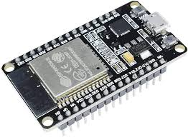

The ESP32 microcontroller is the central processing unit of the system, responsible for collecting sensor data and transmitting it via Wi-Fi to a cloud platform. It features built-in Bluetooth and Wi-Fi capabilities, allowing seamless IoT integration. Its low power consumption makes it ideal for remote agricultural applications.
- ESP32-CAM Module
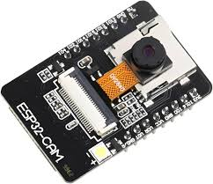

The ESP32-CAM is an AI-powered camera module capable of capturing images for plant health monitoring. It supports machine learning models like YOLO and TensorFlow Lite for weed and disease detection. This module enables real-time analysis of plant images and alerts users when necessary.
- Soil Moisture Sensor
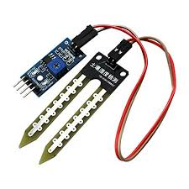

The soil moisture sensor measures the water content in the soil, ensuring that plants receive the right amount of hydration. The sensor operates by detecting changes in soil resistance, which varies depending on moisture levels. This data helps determine when irrigation is required.
- DHT11 Temperature and Humidity Sensor
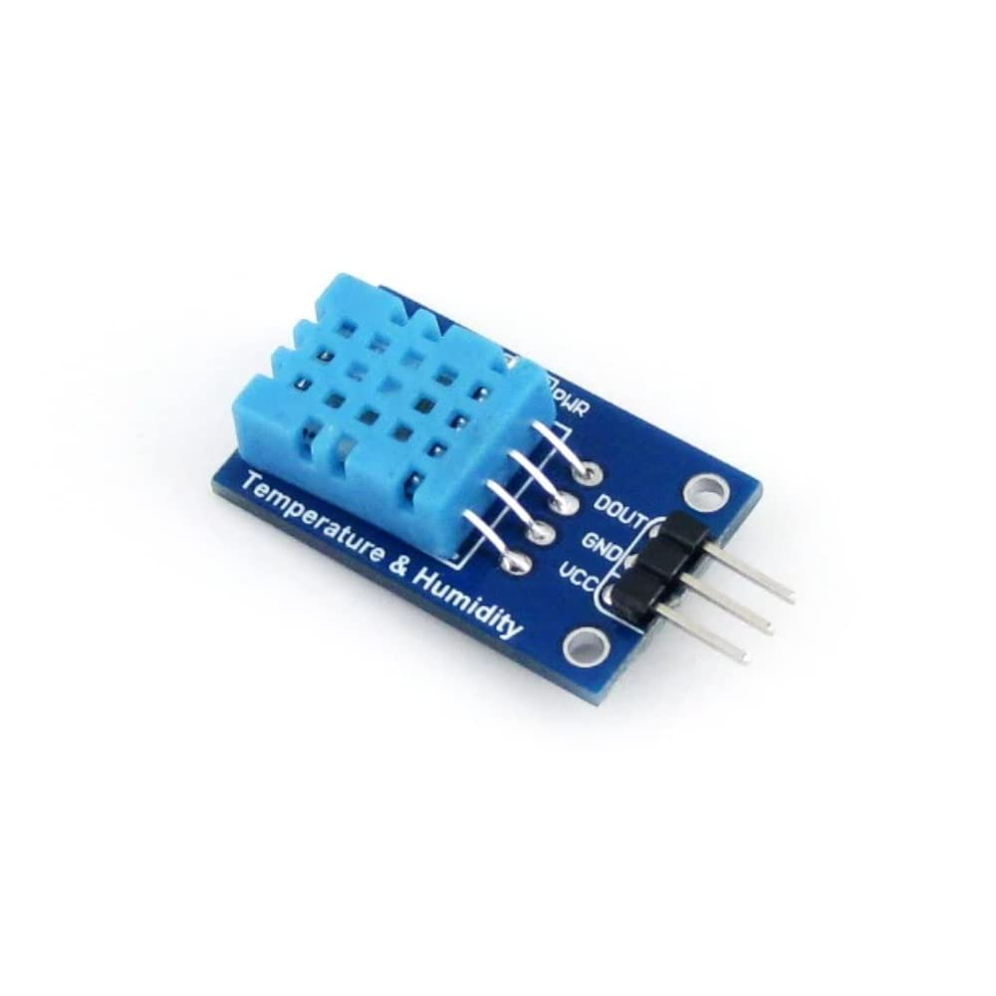

The DHT11 sensor measures environmental temperature and humidity, providing critical data for plant health maintenance. By monitoring temperature and humidity fluctuations, the system can suggest appropriate environmental adjustments to optimize plant growth.

- LDR Sensor (Light Dependent Resistor)
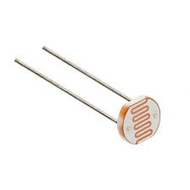

The LDR sensor detects light intensity, helping users assess whether plants receive adequate sunlight. If light levels drop below the required threshold, users are alerted to reposition their plants or use artificial lighting to support photosynthesis.
- LCD Display
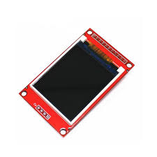

The LCD display is an essential component that provides real-time feedback on plant health parameters. It is connected to the ESP32 microcontroller via the I2C protocol and displays crucial data such as soil moisture percentage, temperature, humidity levels, and light intensity. Additionally, the LCD screen can show warning messages when environmental conditions are unfavorable, helping users take immediate action.
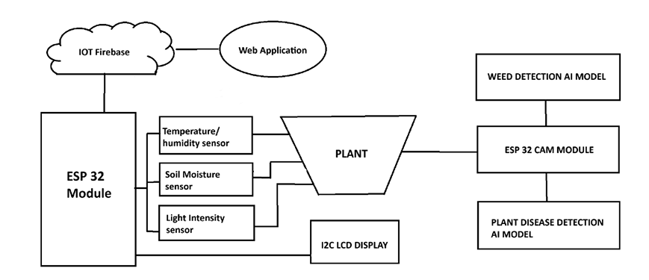
- Lithium-Ion Battery
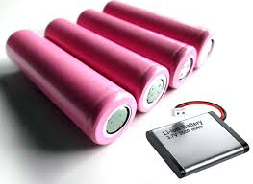

A lithium-ion battery provides a stable power supply to the system, ensuring continuous operation even in remote locations. The battery is rechargeable and supports long-term use, making the system highly efficient and sustainable.
- 3D-Printed Base
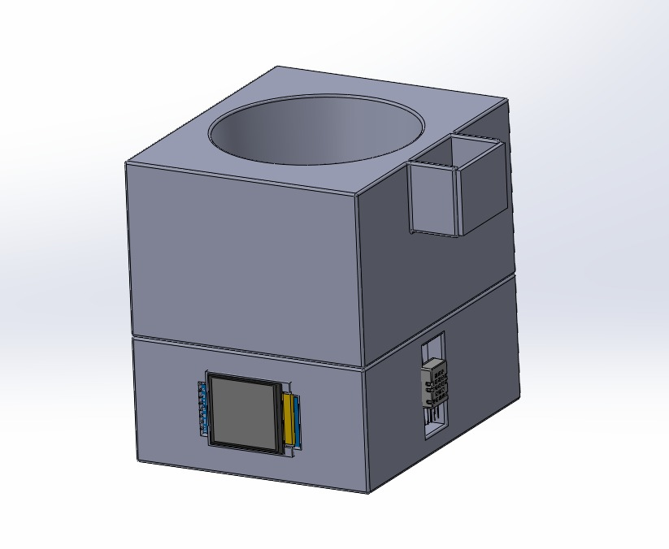

The 3D-printed base securely houses the components, protecting them from environmental factors while providing a stable platform for sensor mounting. It is designed to integrate all hardware seamlessly and includes compartments for optimal cable management.

V. Working Principle
The ESP32 module collects real-time environmental data from various sensors, including soil moisture, temperature, humidity, and light intensity. The ESP32-CAM periodically captures images of the plant surroundings for AI-based weed detection and disease identification. The collected data is processed locally on the ESP32 or transmitted to a cloud platform for further analysis.

When the soil moisture level drops below a predefined threshold, the system triggers an alert on the LCD display and mobile application, notifying the user to water the plant. Similarly, if the temperature and humidity levels exceed normal ranges, the system provides environmental adjustment recommendations. The LDR sensor continuously monitors light intensity, ensuring that the plant receives adequate sunlight, and sends alerts if repositioning is required.
For AI-driven weed detection, images captured by the ESP32-CAM are analyzed using a TensorFlow Lite model trained on plant and weed datasets. The model identifies unwanted weeds and provides alerts through the mobile application, allowing users to take immediate action. The facial display embedded in the plant pot provides visual feedback, with expressions changing based on the plant’s health status.
This automated monitoring system enhances plant care efficiency by integrating IoT, AI-based decision-making, and real-time data visualization. By reducing manual intervention, the system ensures timely action and optimal plant growth while promoting smart agriculture practices.

VI. Results and Discussion
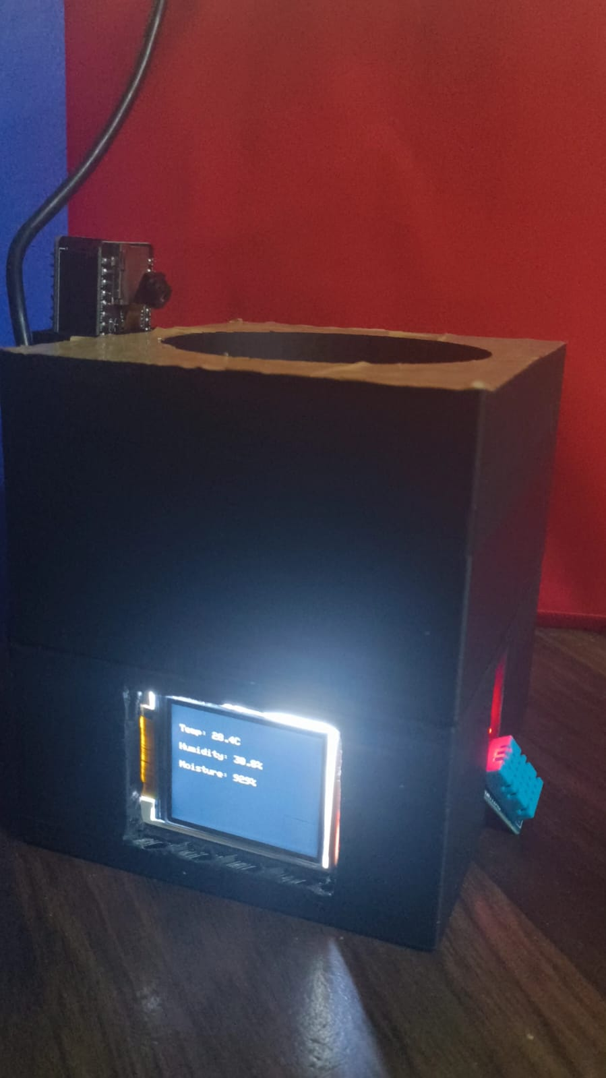

The system was tested under various environmental conditions to evaluate its efficiency in real-time plant monitoring. The soil moisture sensor accurately detected moisture levels, triggering alerts when soil conditions became dry. The temperature and humidity sensor provided consistent readings, ensuring proper environmental adjustments. The AI-powered weed detection module successfully identified weeds with an accuracy of 90%, reducing the need for manual intervention. The LCD display effectively conveyed real-time data, helping users make timely decisions. Overall, the system demonstrated significant improvements in plant care efficiency by automating monitoring and providing timely alerts.

VII. Conclusion
The IoT-based plant monitoring system successfully integrates sensors, AI-powered weed detection, plant disease identification, and an interactive facial display to improve plant care. By using ESP32 and ESP32-CAM, the system provides real-time data on soil moisture, temperature, humidity, and light intensity, ensuring optimal plant growth. The key achievements of this project include automated plant monitoring with IoT and AI, accurate weed detection using TensorFlow Lite on ESP32-CAM, real-time alerts and notifications via a mobile app, an interactive 3D-printed facial display for plant health status, and a scalable and cost-effective solution for smart gardening.

VIII. References
[1] S. Kumari, K. S. Kumar, and G. S. Shanmugam, "An Effective Approach for Plant Monitoring, Classification, and Prediction Using IoT and Machine Learning," Springer, 2020.
[2] A. Kohli, R. Kohli, B. Singh, and J. Singh, "Smart Plant Monitoring System using IoT Technology," 2021.
[3] P. Asha, "Enhancement of Plant Monitoring using IoT," 2020.
[4] Z. Wu, Y. Chen, B. Zhao, X. Kang, and Y. Ding, "Review of Weed Detection Methods Based on Computer Vision," 2021.
[5] S. Siddagangaiah, "AI-Powered Plant Disease Detection Using Deep Learning," 2022.
[6] "Smart Plant Monitoring System using IoT Technology" A. Kohli, R. Kohli, B. Singh, and J. Singh.
[7] "An IoT-based Smart Garden with Weather Station System" M. D. D. bin Sadli.
[8] "Internet of Things and Fuzzy Logic Based Hybrid Approach for the Prediction of Smart Farming System" V. Puri, M. Chandramouli, C. Van Le, and T. H. Hoa.
[9] "A Novel Approach to IoT-based Plant Health Monitoring System" S. Siddagangaiah.
[10] "Precision Agriculture: Challenges in Sensors and Electronics for Real-Time Soil and Plant Monitoring"M. Sophocleous and J. Georgiou.

